21.Write a LEX specification file to take input C program from a .c file and count tthe number of characters, number of lines & number of words.
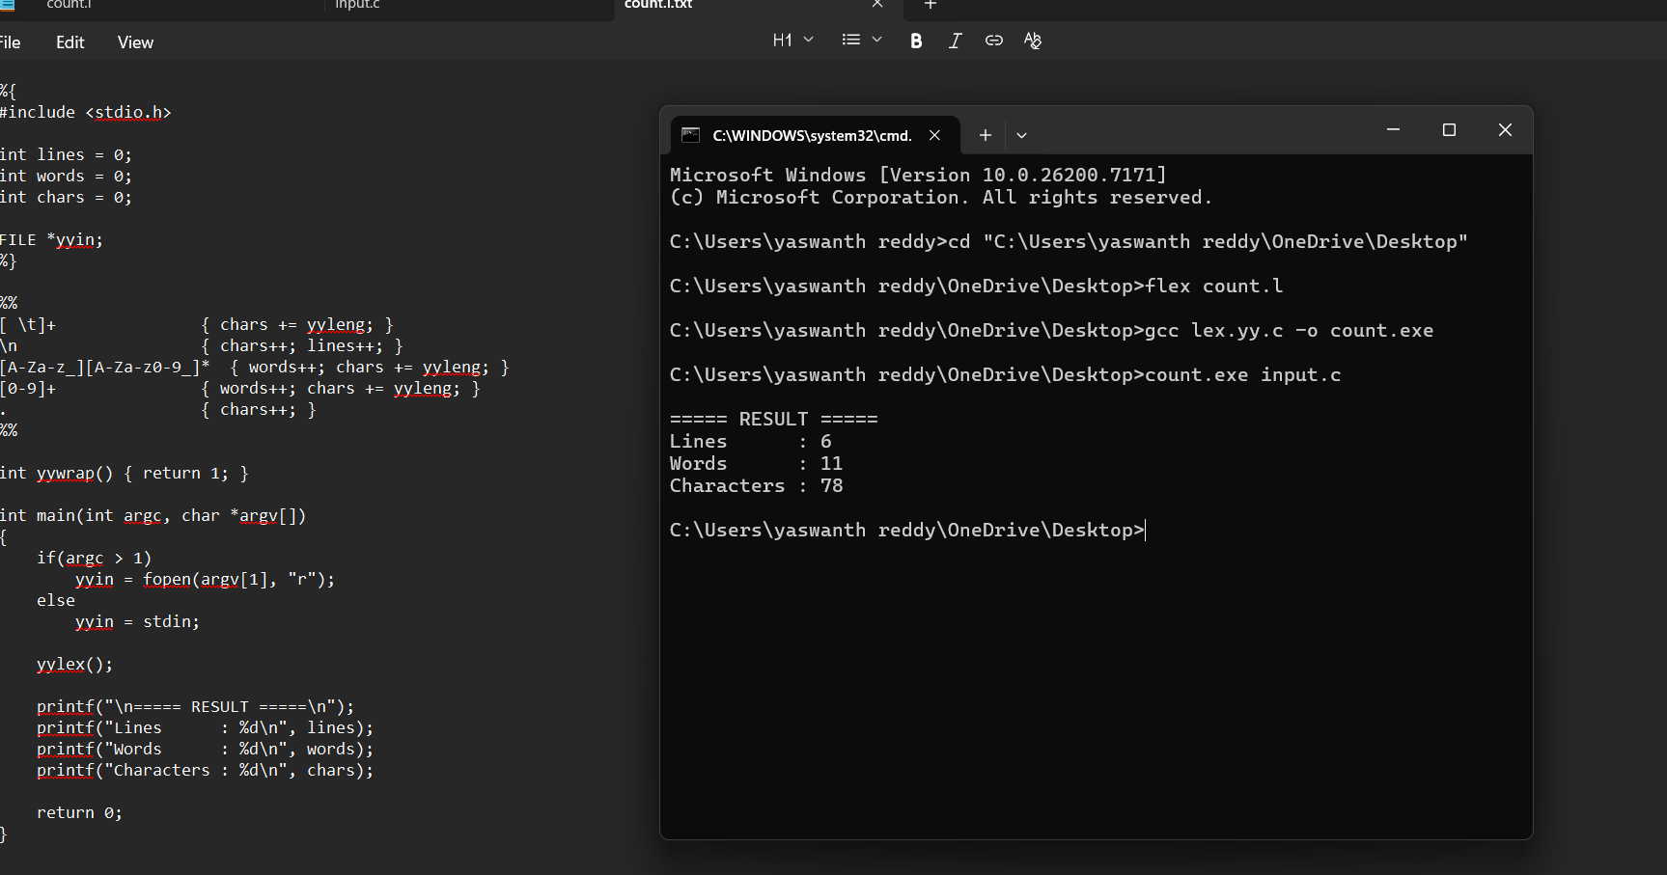
Exp. No. 22
Write a LEX program to print all the constants in the given C source program file.
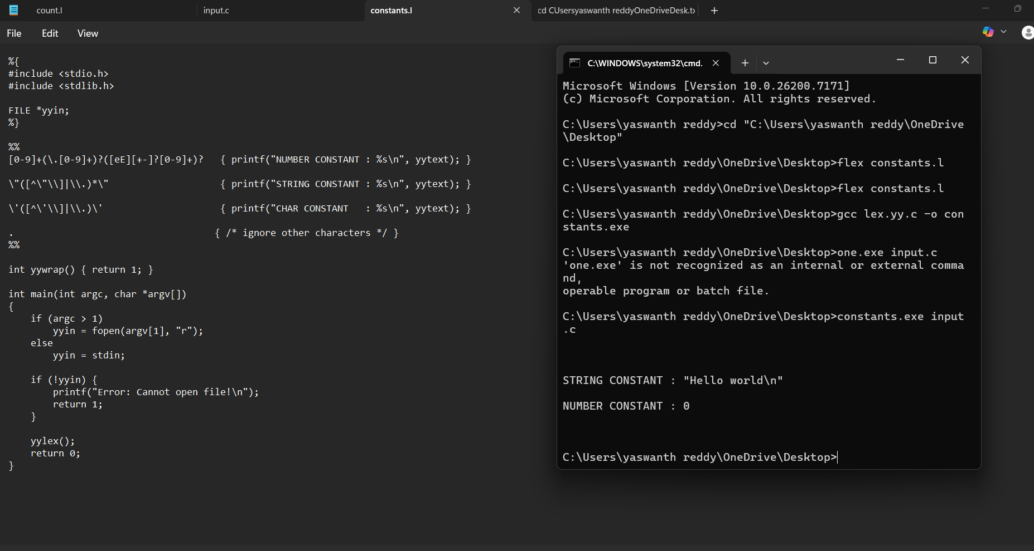

Exp. No. 23
Write a LEX program to count the number of Macros defined and header files included in the C program.
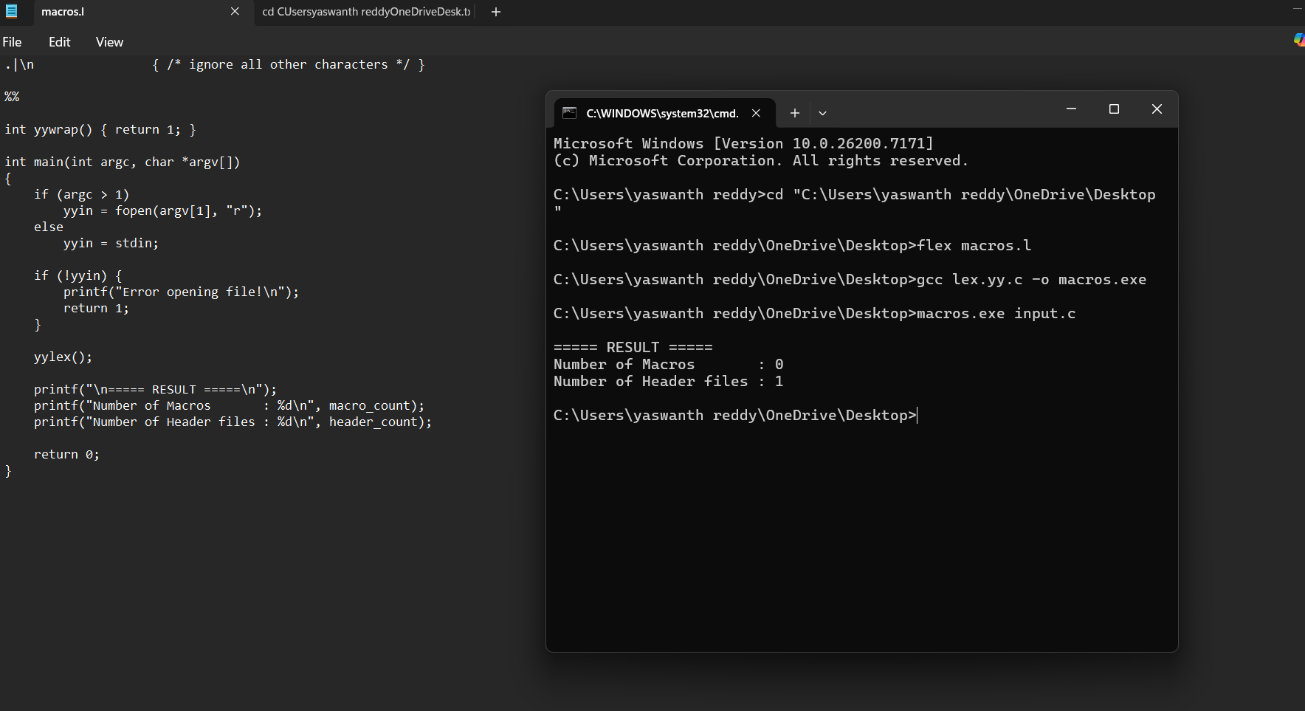
Exp. No. 24
Write a LEX program to print all HTML tags in the input file

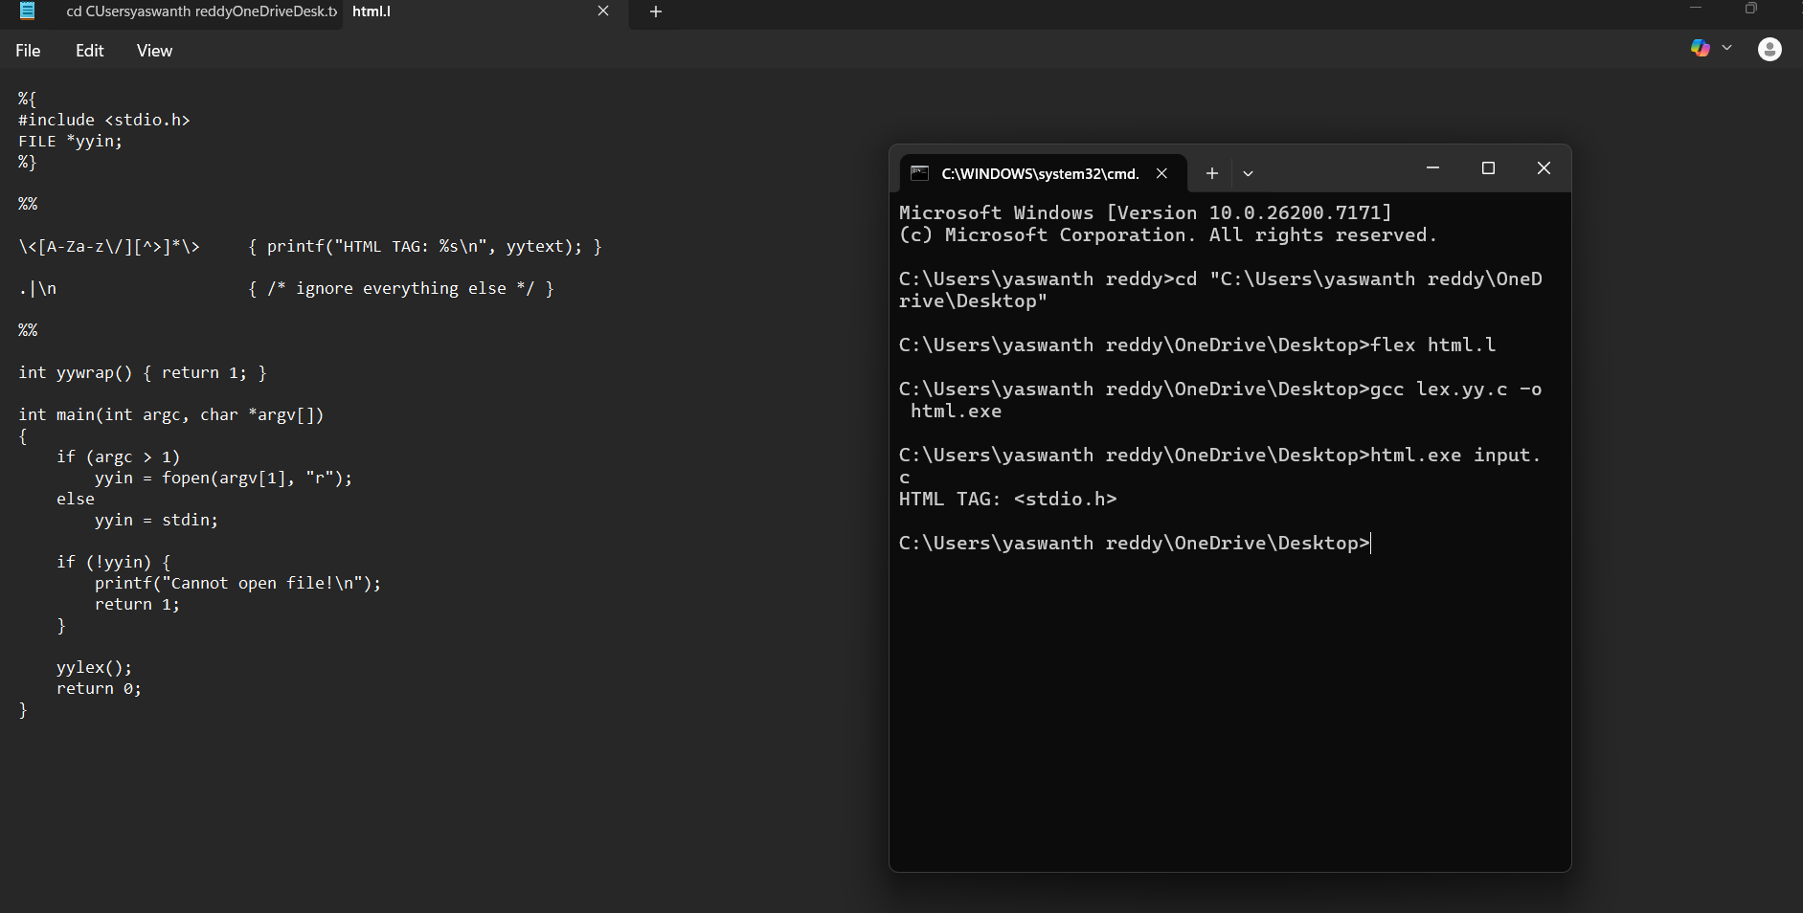

Exp. No. 25
Write a LEX program which adds line numbers to the given C program file and display the same in the standard output 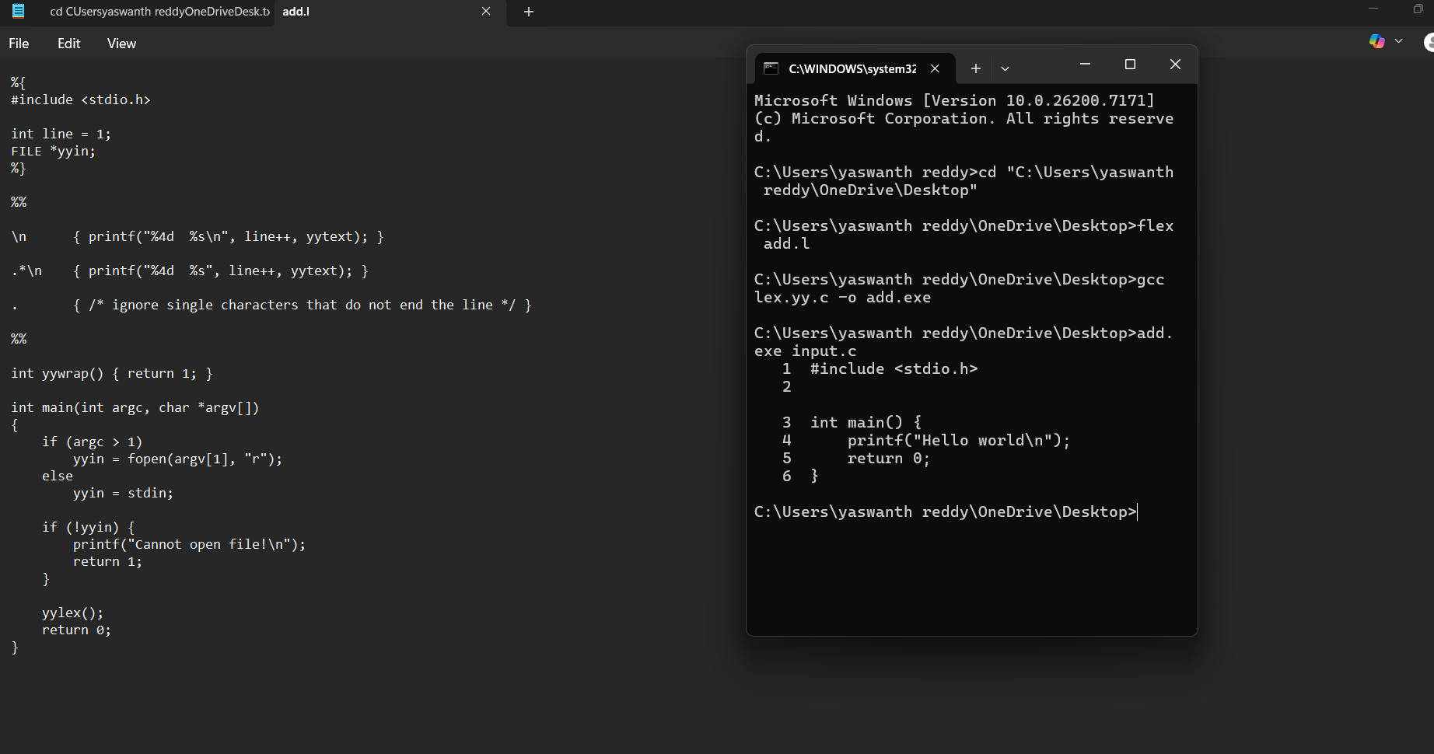
Exp. No. 26
Write a LEX program to count the number of comment lines in a given C program and eliminate them and write into another file
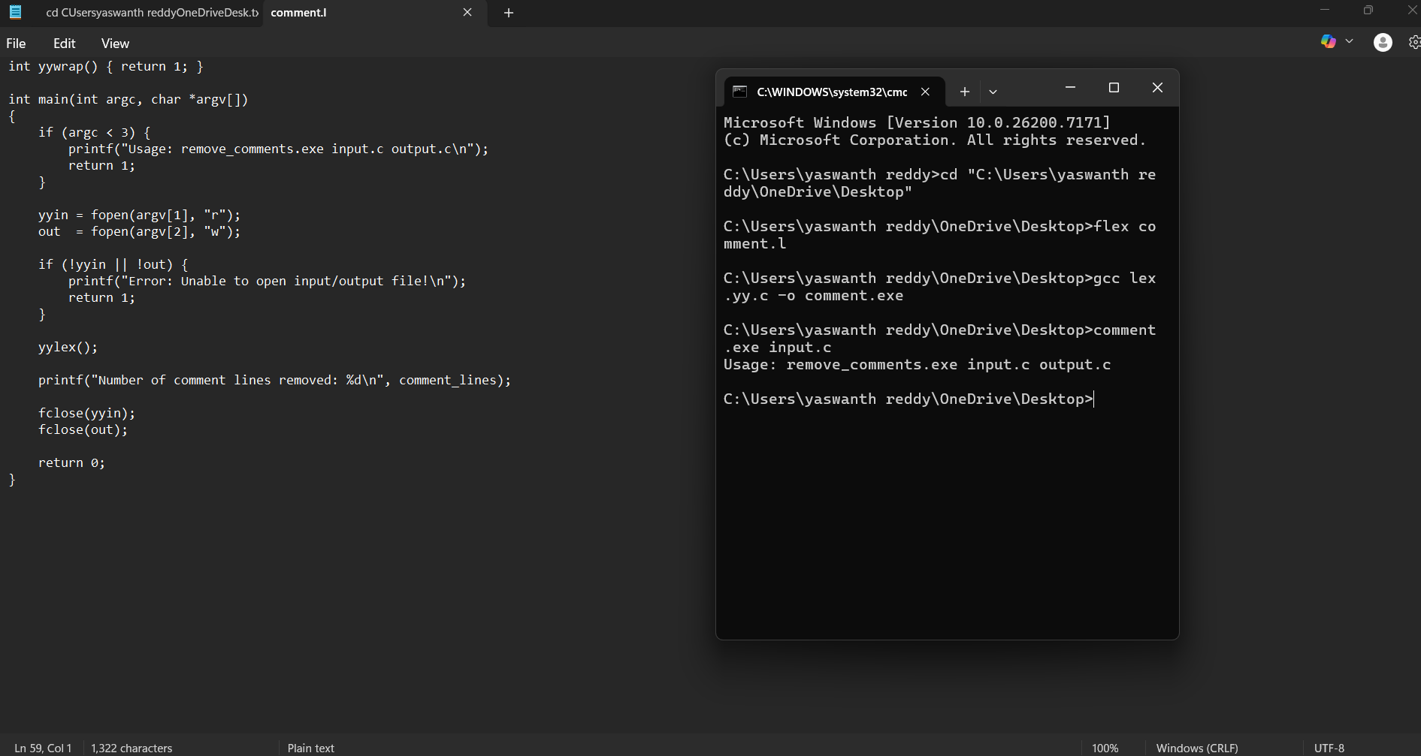

Exp. No. 27
Write a LEX program to identify the capital words from the given input.
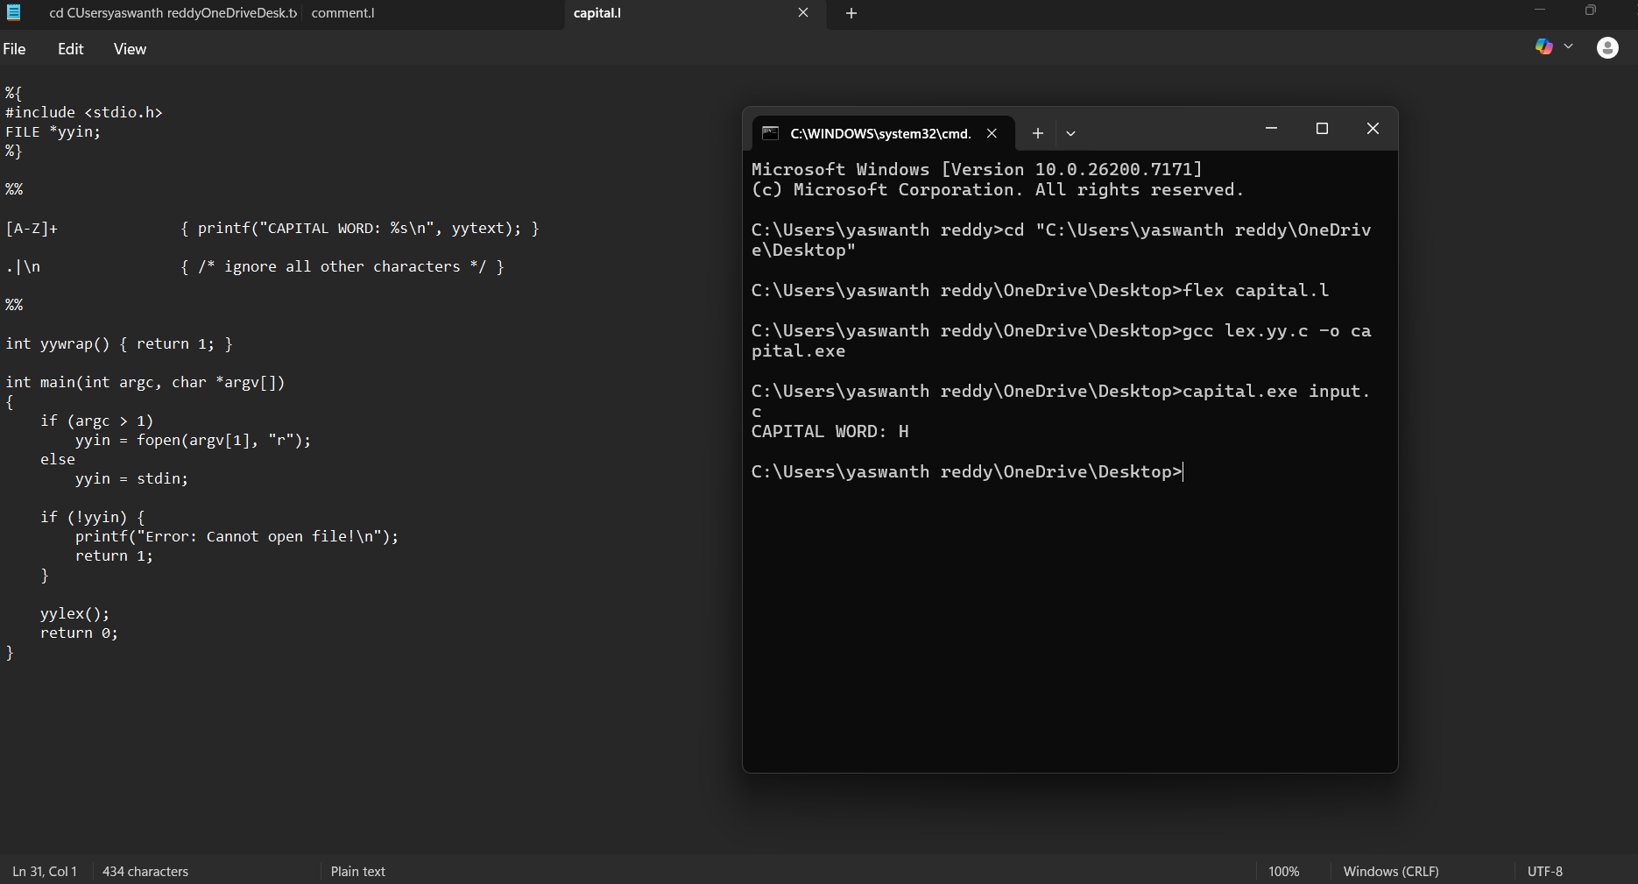
Exp. No. 28
Write a LEX Program to check the email address is valid or not.
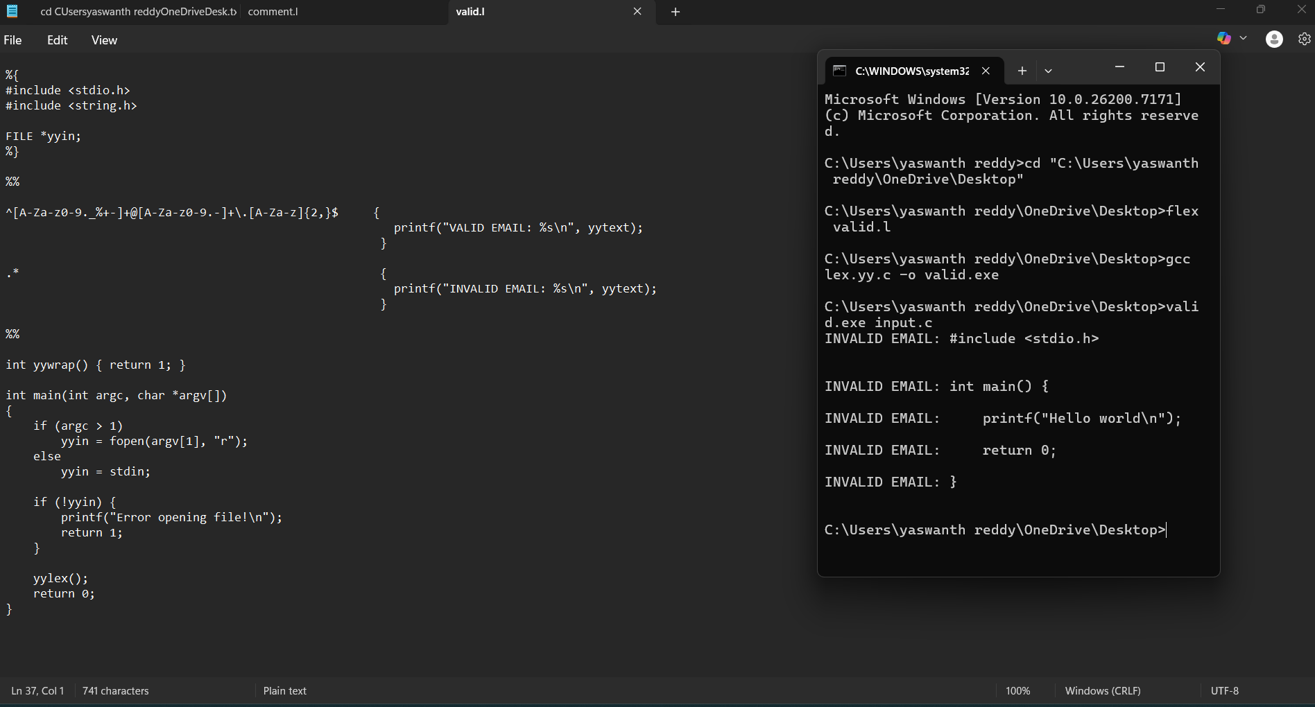

Exp. No. 29
Write a LEX Program to convert the substring abc to ABC from the given input string
Exp. No. 30
Implement a LEX program to check whether the mobile number is valid or not.
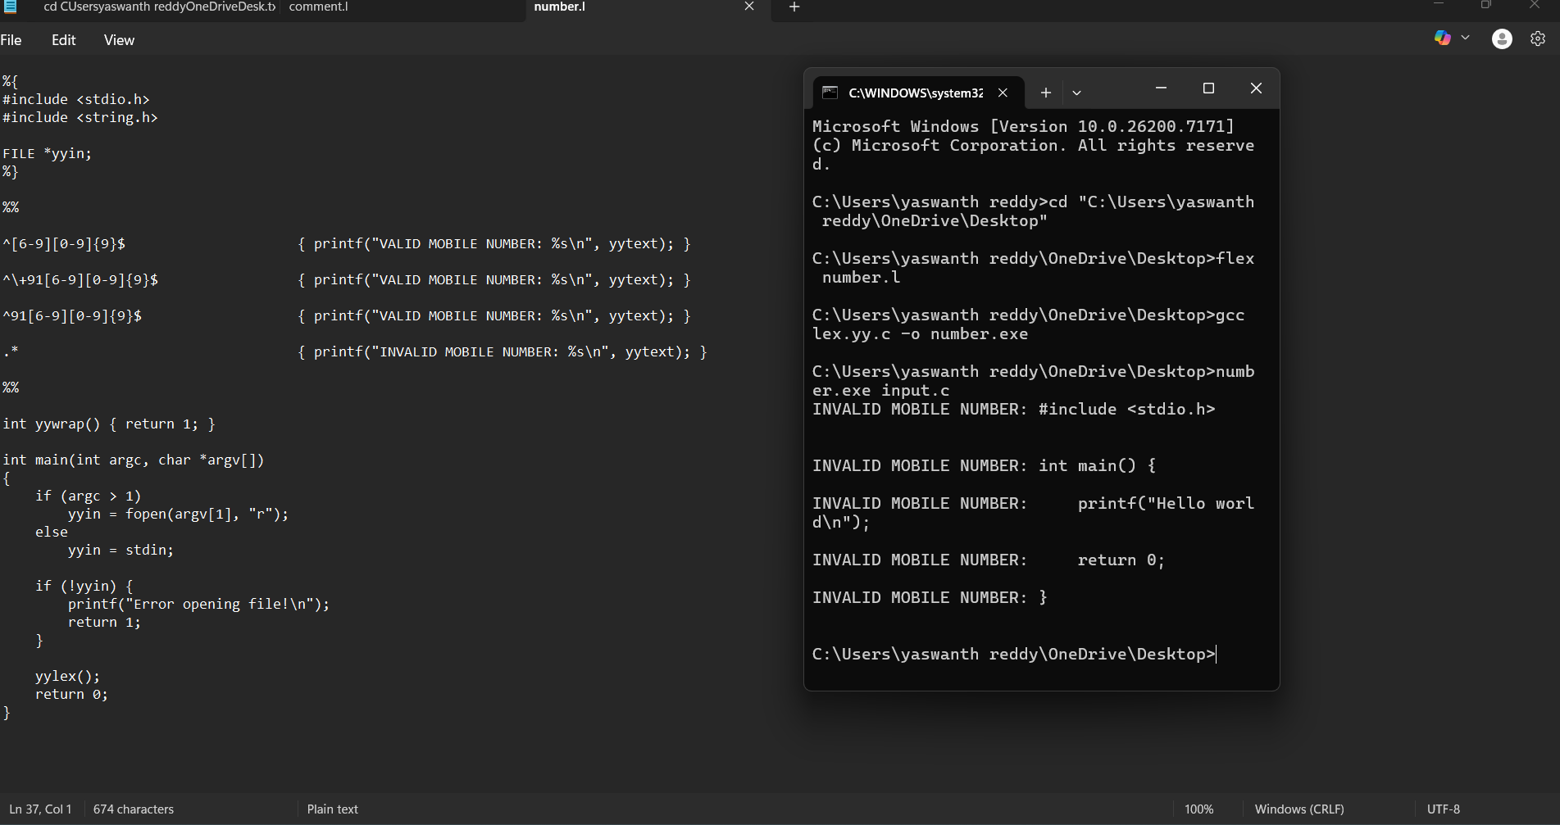

Exp. No. 31
Implement Lexical Analyzer using FLEX (Fast Lexical Analyzer). The program should separate the tokens in the given C program and display with appropriate caption.
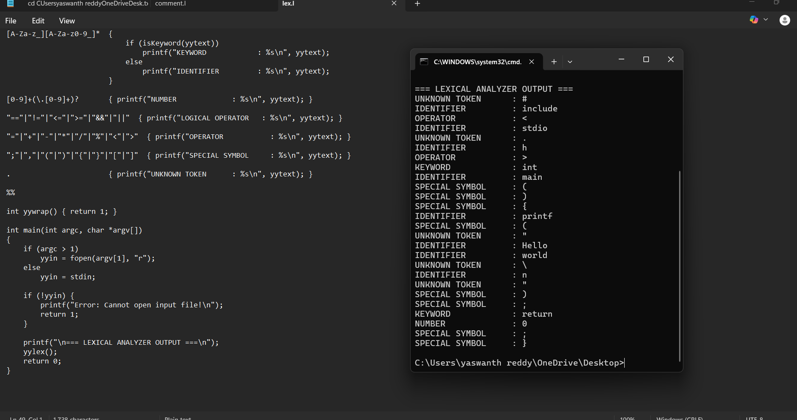
Exp. No. 32
Write a LEX program to count the number of vowels in the given sentence 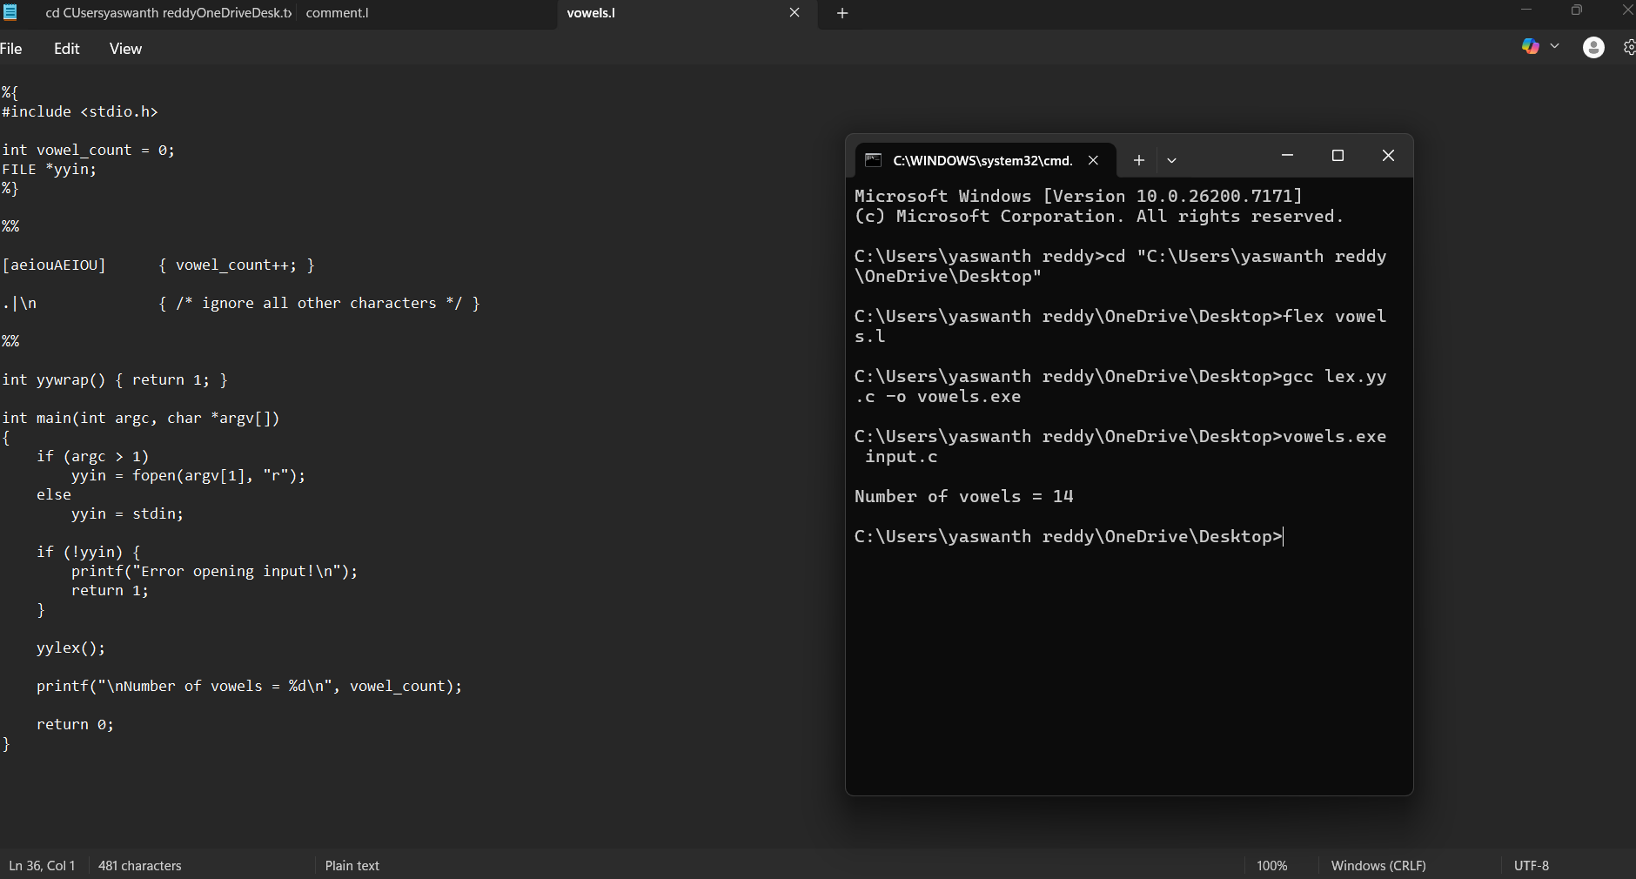

Exp. No. 33
Write a LEX program to count the number of vowels in the given sentence
Exp. No. 34
Write a LEX program to separate the keywords and identifiers.

35.Write a LEX program to recognise numbers and words in a statement. 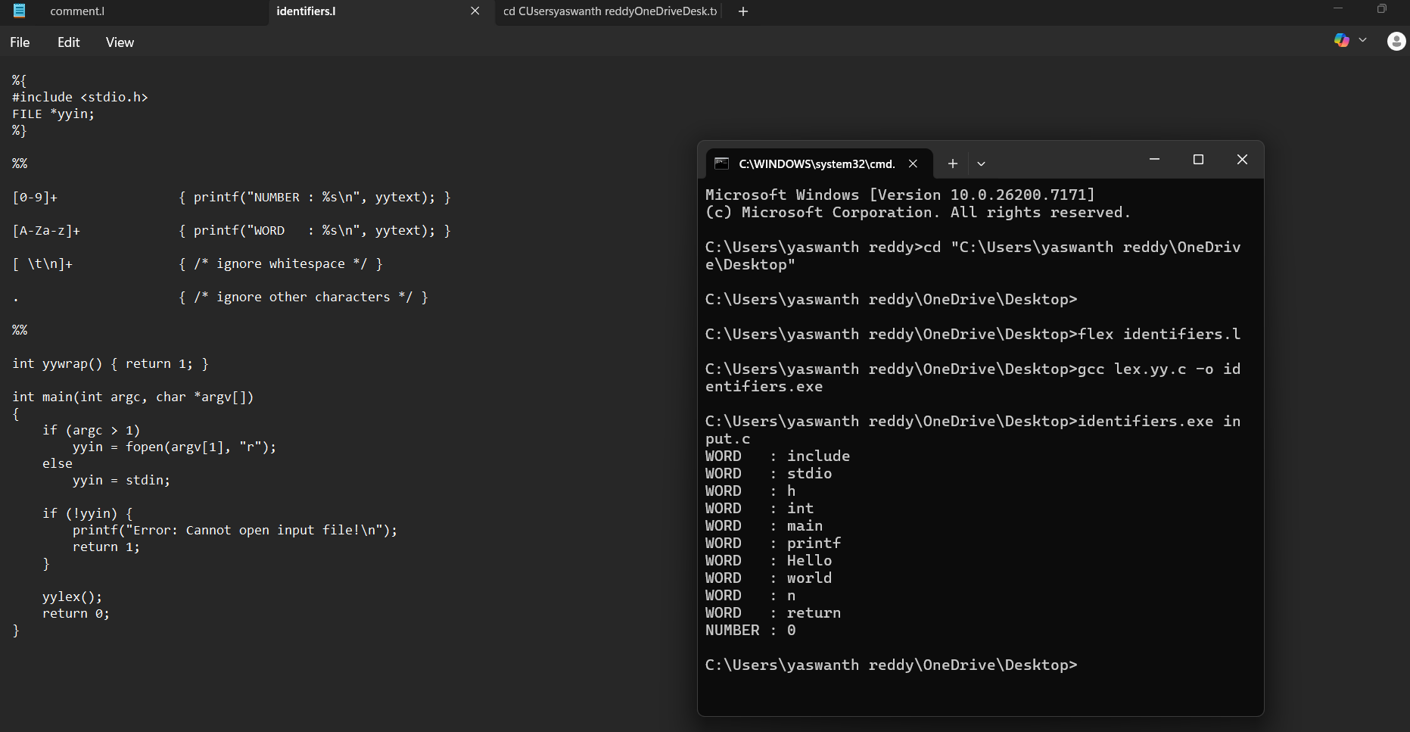 Exp. No. 36
Write a LEX program to identify and count positive and negative numbers.
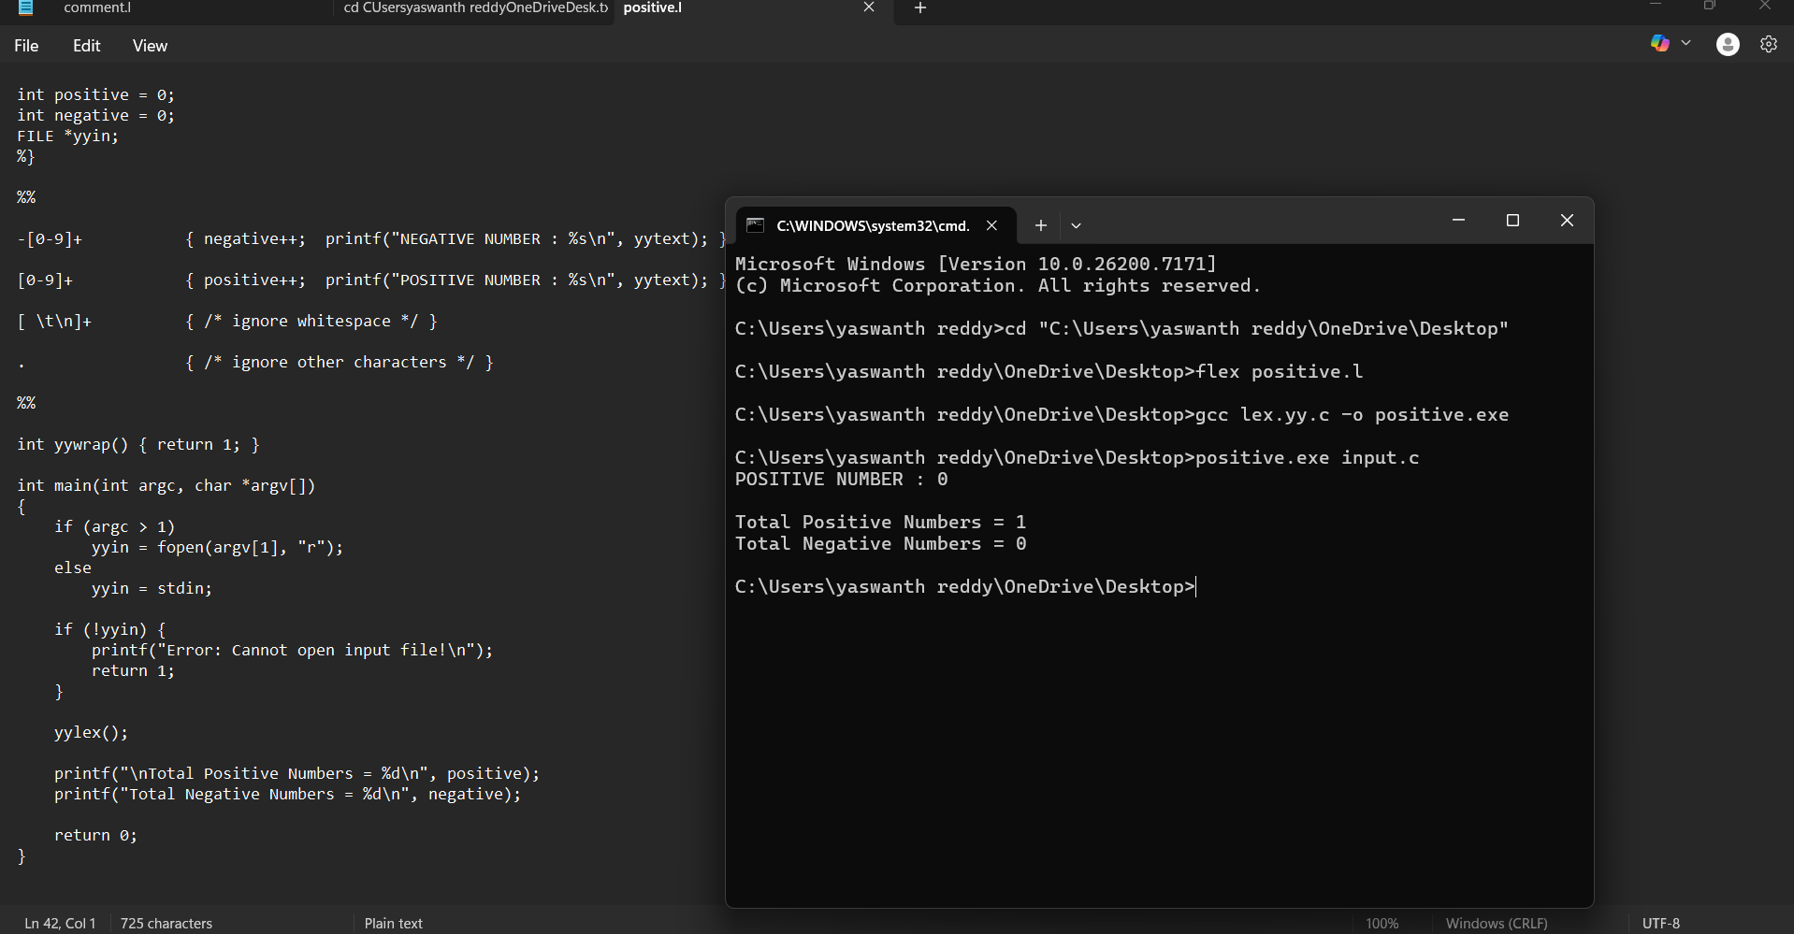

Exp. No. 37
Write a LEX program to validate the URL.
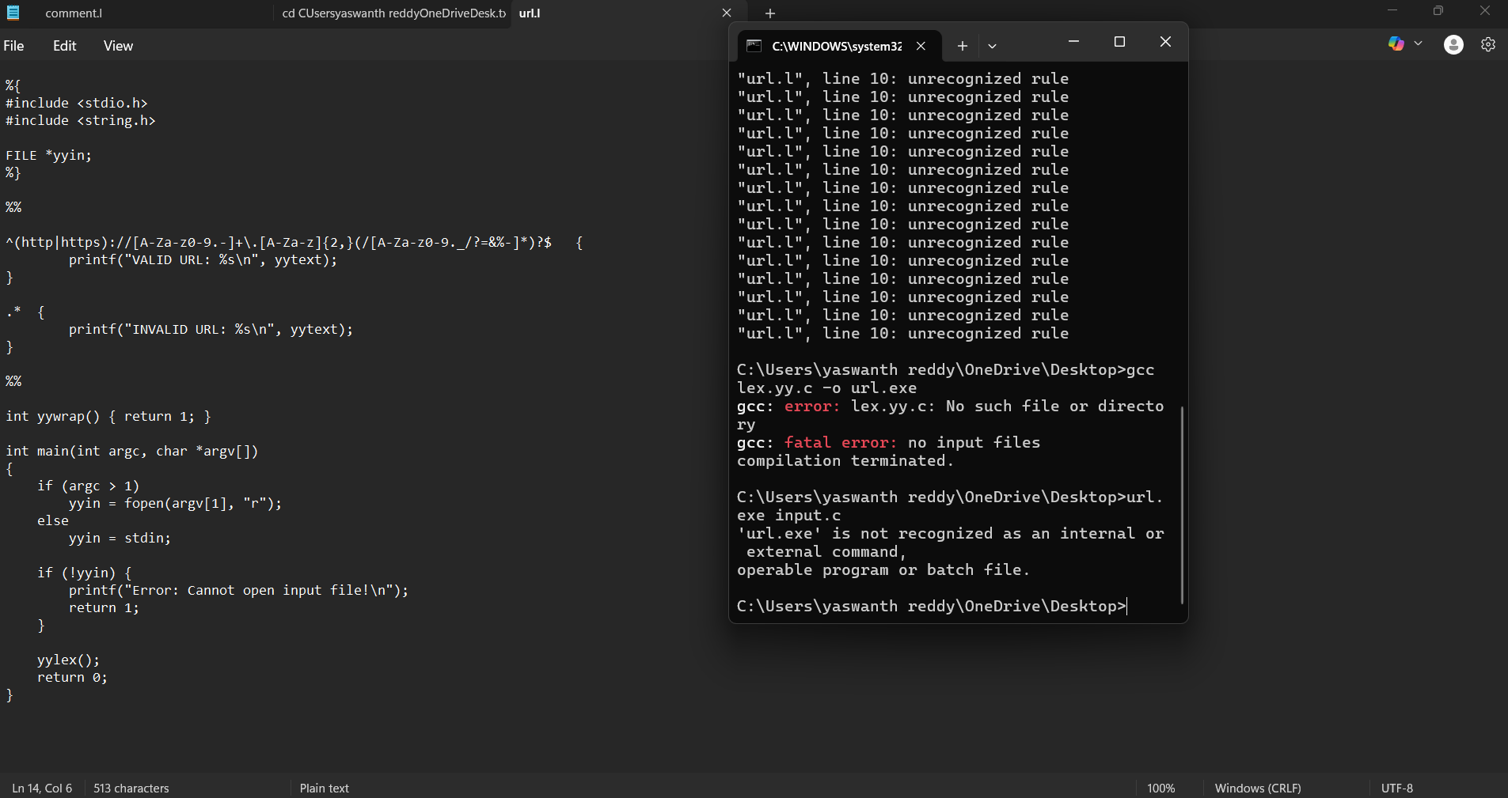
Exp. No. 38
Write a LEX program to validate DOB of students 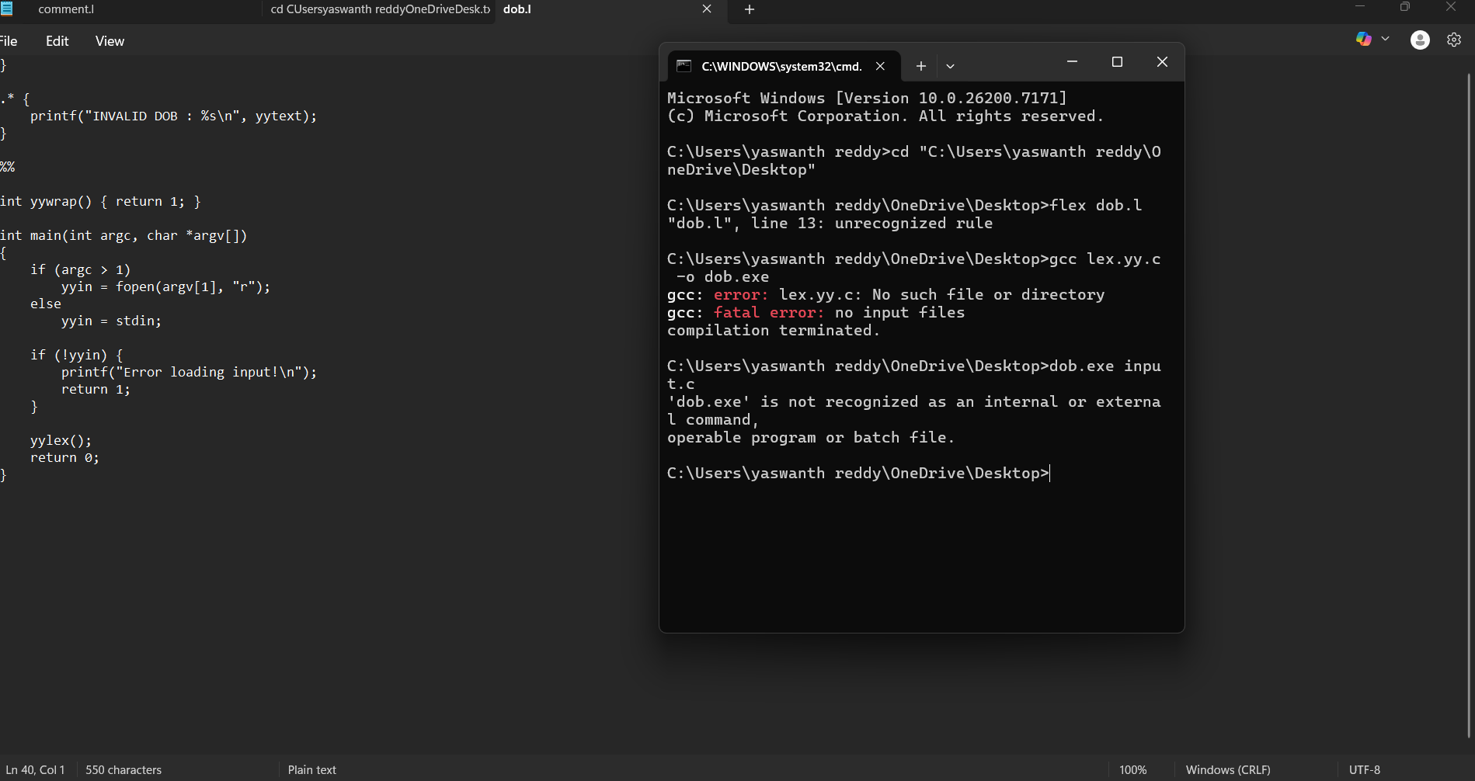

Exp. No. 39
Write a LEX program to check whether the given input is digit or not.
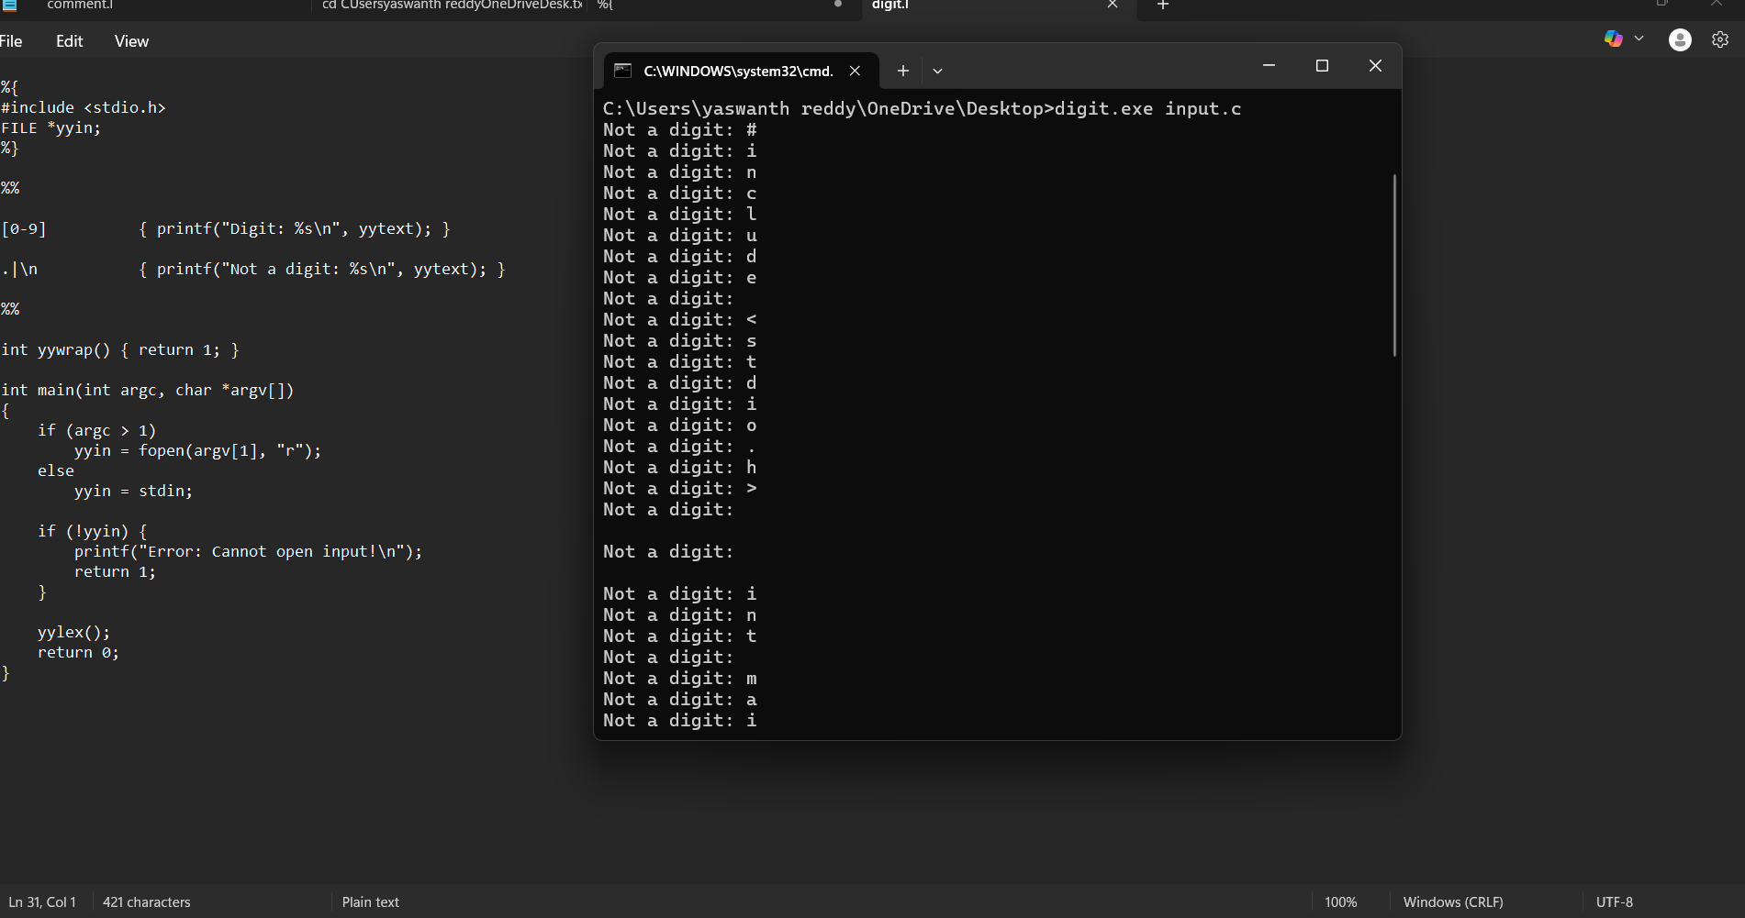
Exp. No. 40
Write a LEX program to implement basic mathematical operations.
